1. 
2. Starter Dependency resolves the following problems:
   1. Will also include transitive dependencies.
   2. Will handle the compatibility for the transitive dependencies.
3. 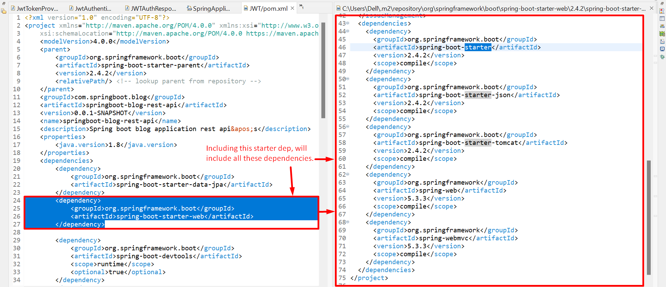
4. 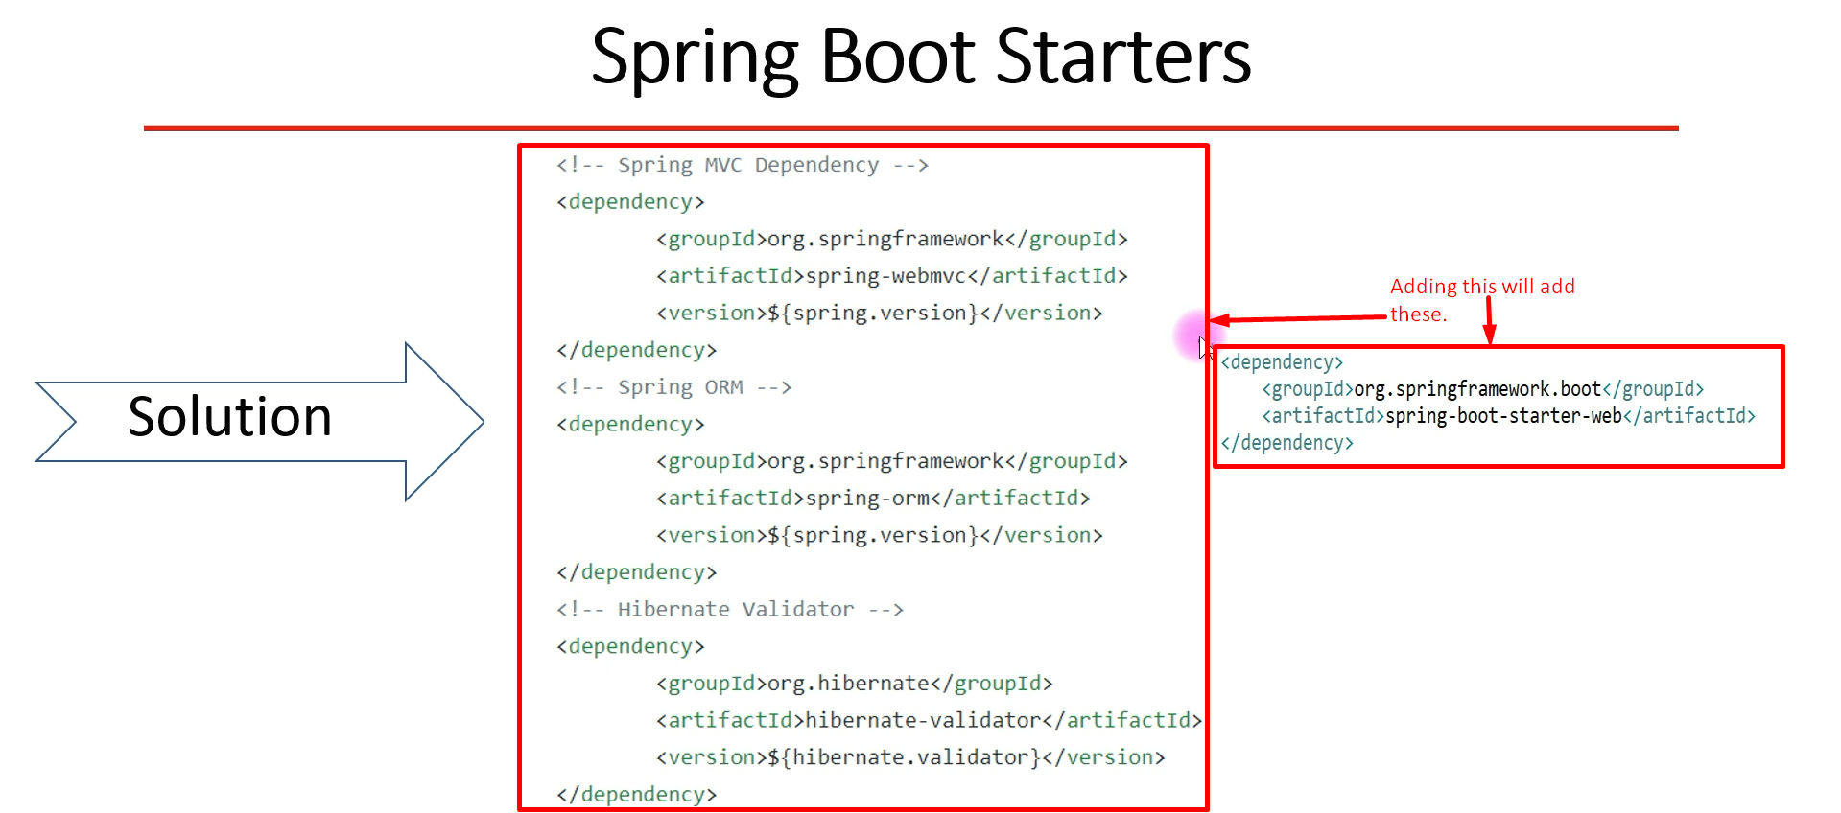
5. Some Starter Dependencies:
   1. spring-boot-starter-<name>  
      spring-boot-starter-web  
      spring-boot-starter-data-jpa  
      spring-boot-starter-test  
      spring-boot-starter-security
6. 